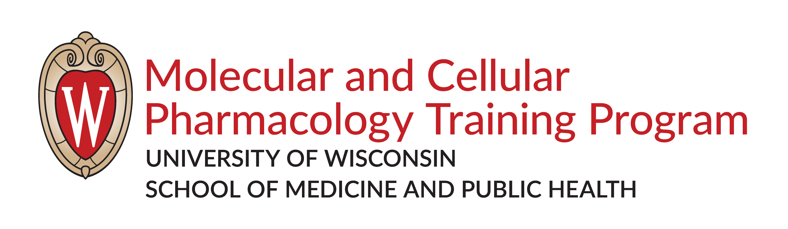

Annual Progress to Degree Form
The purpose of this evaluation is to provide a mechanism for the student to learn about their overall progress to degree and identify areas of strengths and weakness in the student’s development as an independent scientist. Please see the “Doctoral Degree Requirements” section of the handbook for details about the Committee Meeting.
- Complete the Annual Committee Meeting by August 31 of each year.
- Schedule meeting, reserve room and/or sending meeting link, and notify committee members and MCP Office.
- Distribute the project summary and a completed copy of this form to all committee members at least one week prior to meeting.
- During the meeting, a discussion with the student should occur with the Advisor/PI out of the room. This conversation provides an opportunity for the student to confidentially discuss any concerns with the advisor/laboratory/peers, as well as issues related to work-life balance or mental health. For mental health, MCP suggests that students visit https://www.uhs.wisc.edu/mental-health/
- Submit a completed copy of this form to the MCP Office or an enrollment hold may be placed in the student record.

Section 1: Basic Information
Student Name:
Date of Meeting:
PI/Advisor Name:
Other Committee Members:

Brief Research Description (1-2 sentences):

Expected PhD Defense Date:
Has the student created an IDP and updated it within the past year? (An Individual Development Plan (IDP) is required for all students in the MCP program and required for any graduate student supported by NIH funding.) Place an X by the response you want to select.
❍ Yes
❍ No

Section 2: Accomplishments and Goals during past year (Completed by student).

List of Presentations, Honors, and Awards (Examples: NIH training grant, fellowships, campus or national awards, etc. Include date, event, and title of seminar/event.):

List of Publications (please provide full references of work that is published or submitted):

List of Other Activities (Examples: teaching experience, participation in organizations or on committees, professional or volunteer experience):

Progress to Degree (Completed by student. What do you think is required to complete your PhD? What further resources do you need to accomplish that goal? How do you intend to remedy any deficiencies that you have toward that goal? What are your plans for the coming year?):

Section 3: Goals Assessment (Completed by the thesis committee).
Please assess the student's progress on each program learning goal based on expectations for this stage of their graduate career. Place an X by the response you want to select for each goal below:
- Exhibit a broad understanding of the pharmacological principles that underlie all biological processes.
❍ Exceeds expectations
❍ Meets expectations
❍ Does not meet expectations
- Aware of current limitations of this discipline and strategies required to advance the field of pharmacology.
❍ Exceeds expectations
❍ Meets expectations
❍ Does not meet expectations
- Create new approaches in research, scholarship, or performance to extend knowledge in their field.
❍ Exceeds expectations
❍ Meets expectations
❍ Does not meet expectations
- Conduct independent research using a breadth of pharmacological processes.
❍ Exceeds expectations
❍ Meets expectations
❍ Does not meet expectations
- Think critically to address research challenges.
❍ Exceeds expectations
❍ Meets expectations
❍ Does not meet expectations
- Collaborate with other investigators within or outside the thesis lab.
❍ Exceeds expectations
❍ Meets expectations
❍ Does not meet expectations
- Foster ethical and professional conduct in the sciences.
❍ Exceeds expectations
❍ Meets expectations
❍ Does not meet expectations
- Communicate complex ideas in a clear and understandable manner.
❍ Exceeds expectations
❍ Meets expectations
❍ Does not meet expectations
- Explore career development opportunities in industry, government, and academia to realize professional goals and paths.
❍ Exceeds expectations
❍ Meets expectations
❍ Does not meet expectations
- Develop teaching and mentoring skills in lecture, laboratory, and/or outreach settings.
❍ Exceeds expectations
❍ Meets expectations
❍ Does not meet expectations

Overall evaluation of the student’s progress (Includes student’s progress to degree, major strengths and weaknesses, and concerns you may have for the student.):

Please discuss all issues raised in the preceding section with the student. Please describe any suggested plan of action:

Suggested Professional and/or Career Development activities:

Section 4: Signatures
Signature options include: 1) Email and send to each committee member using DocuSign or Adobe. 2) Print and sign by hand. Scan document and email to MCP Office.
Student:
PI/Advisor:
Committee Member:
Committee Member:
Committee Member:
Committee Member:
Committee Member:

