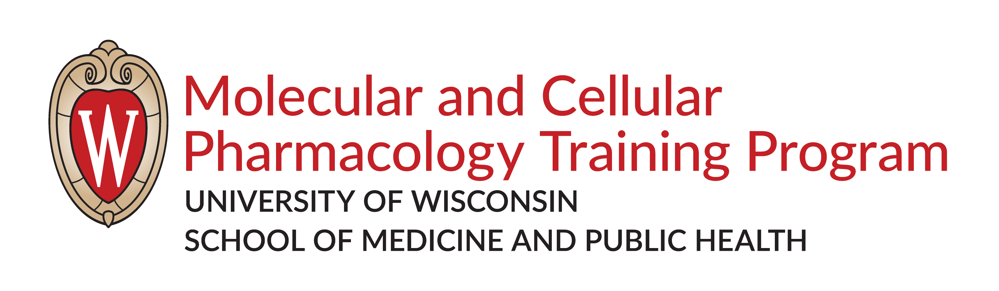
Molecular and Cellular Pharmacology Seminar Series 901
Fall 2026 and Spring 2027
Wednesday from 9:00am – 10:00am
Room: 1345 HSLC
Course Director: Dr. Francisco Alvarado Guillen

 | Date | Name | Advisor/Year
1 | September 2 | Course overview with Dr. Fran Alvarado
2 | September 9 | Kendahl Ott | LeBeau/6th
3 | September 16 | Liam Hurley | Kimple/7th
4 | September 23 | Anu Mattix | Matson/5th
5 | September 30 | Madison Dillerud | Gomez/4th
6 | October 7 | Andrew Schultz | Sinha/6th
7 | October 14 | Jessamine Kuehn | Rey/5th
8 | October 21 | Jayden West | LeBeau/5th
9 | October 28 | Noelle Cataldo | Wenthur/5th
10 | November 4 | Jennifer Koehler | Roopra/5th
11 | November 11 | Loren Lopez Rivera | LeBeau/4th
12 | November 18 | Morgan Pfeffer | McCoy/3rd
13 | November 25 | No Seminar
14 | December 2 | Sarah Lofland | Wu/3th
15 | December 9 | Amanda Allender | Kimple/4th

 | Date | Name | Advisor/Year
1 | January 20 | Liya Mooradian  Madeline Wolfe | Kalogriopoulos/2nd  Wheeler/2nd
2 | January 27 | Xuan Feng | Sheibani/3nd
3 | February 3 | Emma Svendsen  Julia Jimenez | Kosoff/2nd  Hernandez/2nd
4 | February 10 | TBD Invited Speaker
5 | February 17 | Jenna Bowman | Audhya/3rd
6 | February 24 | Paulina Esguerra  Trenton Testerman | Kratz/2nd  Kratz/2nd
7 | March 3 | Boya Chen | Weaver/3rd
8 | March 10 | Audrey Chambers | Zhao/3rd
9 | March 17 | Zachary Nicholson  Shiguang Dai | LeBeau/2nd  Gong/2nd
10 | March 24 | Spring Break - No Seminar
11 | March 31 | Hailey Thurston | Sousa/3rd
12 | April 7 | Mia Corradi  William Stump | Xu/2nd  Sharifi/2nd
13 | April 14 | Miguel Gonzalez | South/3rd
14 | April 21 | Invited Speaker TBD
15 | April 28 | Annual Symposium

